Manila Water Company
FUNCTIONAL SPECIFICATION – FORM

DD_M2C_130
Return Latter
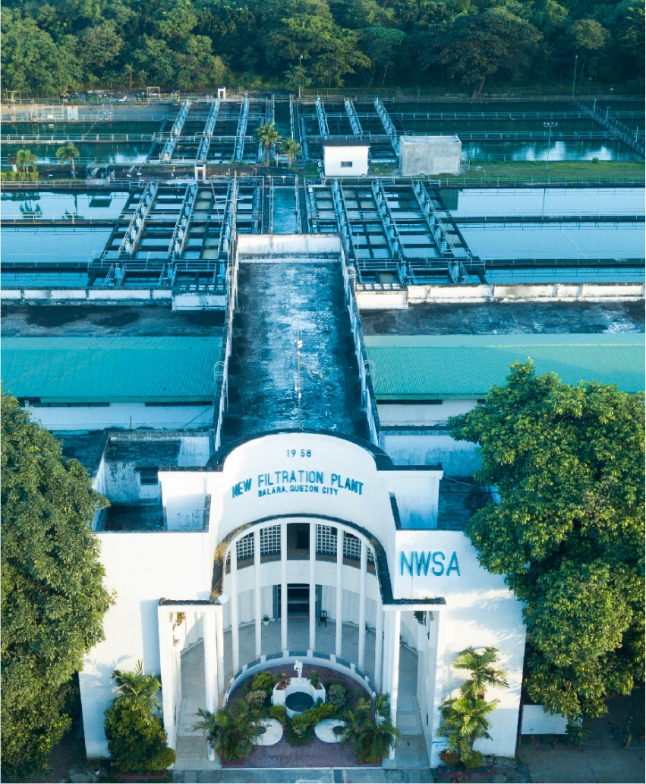

Customer NameDocument Title





[How to use the Template: This chapter gives only explanations on the template. Remove it before completing the template.
Blue text is always intended as instructions, guidelines, explanations, hints, and tips. It should always be removed from the template for the project.
Update Fields in Document: If you want to update all fields, press "CTRL+A," then "F9". You will get pop-ups sequentially, which ask you for the new values. Afterwards go to the footer area, then press "CTRL+A" and "F9" again.
Top-level chapters may not be deleted or inserted; required additions should be made as sub-chapters to existing chapters to provide a consistent representation of this document to the customer. To keep the numbering of the chapters consistent over all specifications (of the project), do NOT delete top-level chapters that are not relevant in a concrete document; only mark them as not relevant (that is, add “not relevant” or “not applicable”).]
[Document Version Status has four values: Draft, Ready for Review, Reviewed with Comments and Final. If the document send by an Author(s) without an intention of a Review should have a status as Draft. A Draft document may have some incomplete sections.
If the document send by an Author(s) with an intention of a Review should have a status as Ready for Review. All the sections in the document are expected to be completed in this case.
Reviewer(s) should set only two statuses:
- Reviewed with Comments – if documents needs to send the document to Author(s).
- Final – marks the acceptance of reviewer for the document.]
You can for example number the appropriate versions as follows:
0.1 Draft
0.2 Ready for Review
0.3 Reviewed with Comments (in case document is send back to author(s)
0.3 Ready for Review (in case of major changes)
1.0 Final

In case of fundamental changes:
1.1 Draft (new draft version that has to pass a review again)
1.2 Ready for internal review
1.3 Ready for Review
2.0 Final

Contents
1.1 Document Log 4
1.2 Integration, Document Reference 4
2 Functional Description 4
2.1 Assumptions 5
2.2 Processing Type 5
2.3 Output Type 5
2.4 Functional Design 5
2.5 Security / Authorization Requirements 6
2.6 Process Flow Diagram 6
2.7 SAP Transaction 6
2.8 Form Layout 6
2.9 Printer Requirements 8
2.10 Legal Requirements 8
2.11 Form Fields 8
2.11.1 Main Heading 11
2.11.2 Sub Heading 11
2.11.3 Totaling 11
2.11.4 Sorting 12
2.11.5 Page Breaks 12
2.11.6 Stationery 12
2.11.7 Logo(s) 12
2.12 Bar Coding Requirements 12
2.13 Email Requirements 12
2.14 Existing Sample Forms 12
3 Assumptions in Functional Design 12
4 Open Issues in Functional Design 12
5 Business Test Conditions 13
6 Related Documentation 13
Document Organization
This section provides details about this document, previous version(s) of this document and the document(s) referred.

Document Log
Following table mentions the version changes and the processer(s):
Version | Status | Date | Version Created by (Name/E-Mail/Company) | Role | Comments
1 | Draft | March 16, 2025 | Srinivasarao.koppaku@sap.com | Author | Initial Draft
2.0 | ​​Ready for Review​ | ​​ March 17, 2025 | Roopali Sharma  roopali.sharma02@sap.com  Mohanrangan  Mohanrangan.rangarajan@sap.com | ​​Reviewer​ | Technical Review

Integration, Document Reference

S. No. | Referred Document Name | Referred Document Version | Referred Document URL (Optional)
 | MWC_SDD_FICA_02_Incoming & Outgoing Payment Processing V2.0 | V2.0

The documents listed here are explicitly not part of this Functional Specification. They are not automatically accepted together with this Specification but may be subject to a separate customer/SAP acceptance.

Functional Description
Customers paid their Bills at Cash desk or at payment facility by cheque. Cheque deposited in the bank and cheque dishonor. MWC send return latter to customers about the return’s latter. MWC print the return latter and send to the customer.
This FS describes the requirements and details of the receipt printing.
To build the payment receipt based on MWC format, the standard form FI_CA_RETURN_SAMPLE_SF (Create Z Form copy of Standard form) and can be utilized & designed based on the MWC specific requirement.

Assumptions
Customers paid at cash desk: in this case receipt will be printed immediately and handover the same to customer.
Customers paid at Payment facility: in this customer approach the nearest service area and request for receipt. MWC agent will print the receipt and handover the same.

Processing Type
This form can be printed after posting the return lots. MWC executives will execute the T code FPCOPARA and it will print the return later in the local printer.

Output Type
From can be printed on local printer.
MWC will use A4 paper for printing the form and no pre-printed stationary.

Functional Design
Customers paid their bills at MWC cash Desk or at Payment facility by cheque.
Cheque deposited in the bank and cheque dishonor. MWC send return latter to customers about the return’s latter. MWC print the return latter and send to the customer.
Standard application form will not fulfill the MWC Return latter printing, so we need develop a custom form (Z*) with copy of the standard from FI_CA_RETURN_SAMPLE_SF.
One common return latter will be applicable for both EZ and NEZ customers.

Security / Authorization Requirements
User should have access to print the Return latter FPCOPARA.

Process Flow Diagram
[Please insert a flow diagram describing the form output procedure e.g. Purchase Order input using transaction ME21N; save Purchase Order automatically generates Purchase Order Form printout]

SAP Transaction

Returns posted through T code FP05 and returns letters can be printed through FPCOPARA.

Form Layout

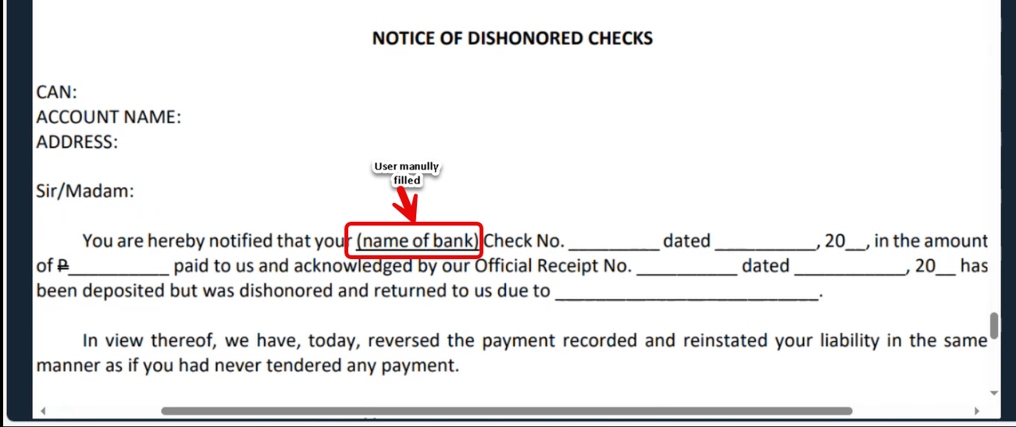
Logic to fill the data
- Check number – Pass DFKKCOH-ENTID2 = OBEL and take DATA2 into DFKKZP- OPBEL and Take- CHCKN value.
- Date: Pass DFKKCOH-ENTID2 = OBEL and take DATA2 into DFKKZP- OPBEL and Take- TXTVW value.
- Official Receipt number: Pass DFKKCOH-ENTID2 = OBEL and take DATA2 and pass into DFKKEXTDOC-EXKEY and take EXBEL value and take document posting date.
- Reason: Pass DFKKCOH-ENTID2 = OBEL and take DATA2 into take DFKKRP- OPBEL and take RLGRD. Pass DFKKRP- RLGRD into TFK045A- RLGRD and take RTEXT.

Printer Requirements
Standard printing requirements

Legal Requirements
No legal requirement.

Form Fields

The custom form will be based on the SAP sample FI_CA_RETURN_SAMPLE_SF.
Form Field ID | Field Name | Type | Source Logic
1. | CAN | Dynamic | Pass DFKKCOH-ENTID2 = OBEL and take DATA2 and pass into DFKKOP-OPBEL and take DFKKOP- VKONT.
2. | Account Name |  | Pass DFKKCOH-ENTID2 = OBEL and take DATA2 and pass into DFKKOP-OPBEL and take DFKKOP-GPART.  Pass GPART into BUT000- PARTNER and take NAME_ORG1, NAME_ORG2, NAME_ORG3  Note: Cross check the Invoice printing logic.
3. | Address | Dynamic | Same as above
4. | Official Receipt Number | Dynamic | Pass DFKKCOH-ENTID2 = OBEL and take DATA2 and pass into DFKKEXTDOC-EXKEY and take EXBEL value and take document posting date.
5. | Check Number and date | Dynamic | Check number – Pass DFKKCOH-ENTID2 = OBEL and take DATA2 into DFKKZP- OPBEL and Take- CHCKN value.  Date: Pass DFKKCOH-ENTID2 = OBEL and take DATA2 into DFKKZP- OPBEL and Take- TXTVW value.
6. | Reason | Dynamic | Reason: Pass DFKKCOH-ENTID2 = OBEL and take DATA2 into take DFKKRP- OPBEL and take RLGRD. Pass DFKKRP- RLGRD into TFK045A- RLGRD and take RTEXT.

Main Heading

NA.

Sub Heading
NA

Totaling
NA

Sorting
NA

Page Breaks
NA- It is single page

Stationery
Plain A4 ( no pre-printed stationary )

Logo(s)
NA

Bar Coding Requirements
NA

Email Requirements
NA

Existing Sample Forms
NA

Assumptions in Functional Design
Bank name: User will enter the bank name. Payment facility provide the dishonor cheque number details to MWC and MWC agent post the return lot manually.

Open Issues in Functional Design
NA

Business Test Conditions

Scenario # | Input Selection Criteria | Expected Result
 | Customer Paid at Cash desk and Cheque dishonored | MWC agent post return lot and print the return letter.
 | Customer Paid at payment facility and Cheque dishonored | MWC agent post return lot and print the return letter through FPCOPARA.

Related Documentation
NA

